1. Fig.1 shows an ac circuit. The various component values are given by: vs(t) = 100 sin[(100π)t], R1 = 500 ohms, R2 = 100 ohms, L = 1.014 H , C = 10 µF.

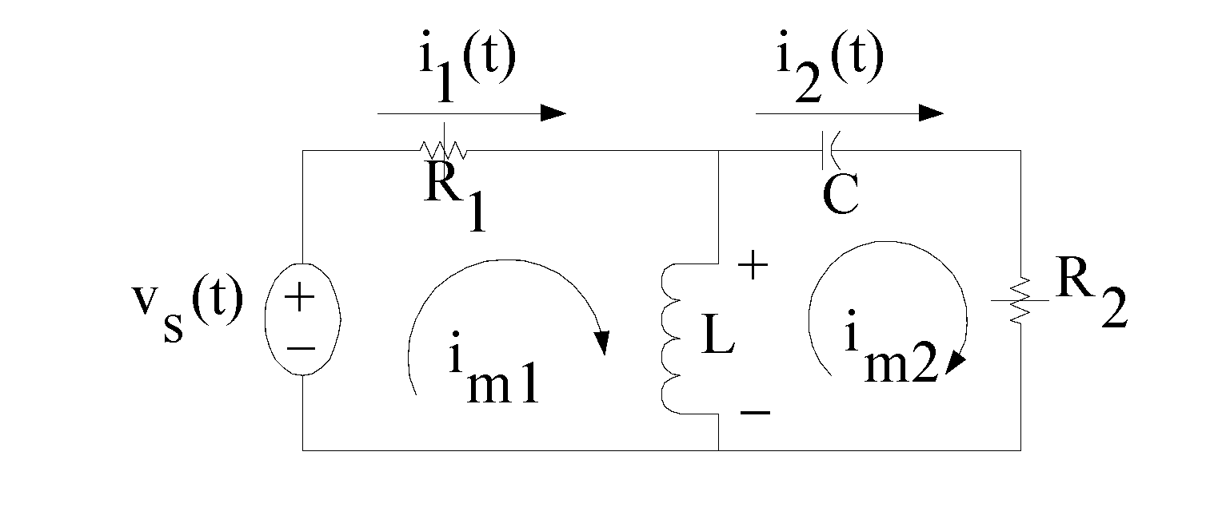

Fig.1.

1. Draw the circuit in phasor form, showing all the values of the components.
2. Write the two mesh equations. (**Only the meshes shown shall be considered).**
3. Calculate the values of I1 and I2.
4. Present a time domain equation for the voltage across the inductor with the polarity indicated in the figure.

(8 marks)

2. For the network shown in Fig.2, (a) Obtain the expression of the input impedance Zab in terms of R1, R2, C1, C2 and the operating frequency ω,

(b) Determine the frequency ωo at which Zab is purely resistive.

(c) At this frequency ωo, obtain the value of Zab = Rab + j0.

The various component values are given by: R1 = 1k ohms, R2 = 1k ohms, C1 = 10-3 F, and L2 = 1 mH. **(ω = 0 and ω = ∞ should not be considered.)**

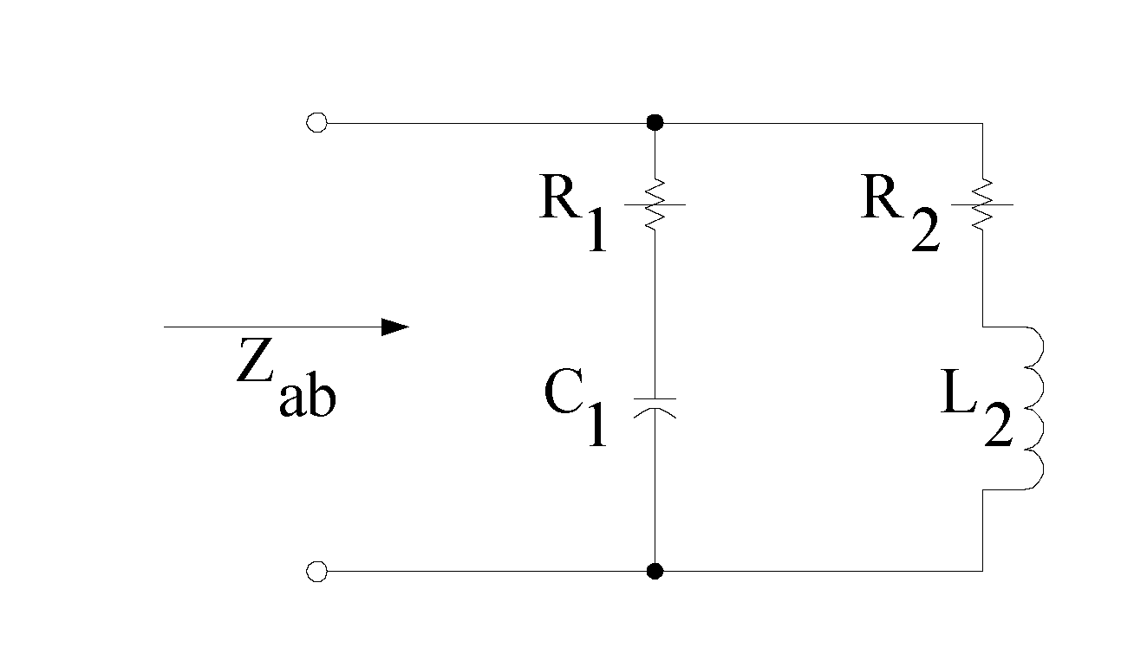

Fig.2.

(9 marks)

**2 of 6/-**

3. Fig.3 shows an electrical network given in the time-domain.

(a) Write the nodal equations using Is1, Is2, Vs, R1, R2, jωL, and (1/jωC).

(c) Using these equations, obtain the values of the node voltages Va, Vb and Vc.

(d) Hence obtain the values of the branch currents I1, I2, I3 and I4.

The various component values are given by: VS = 1 ej0 V, Is1 = 1 ej0 mA, Is2 = 2 ej0 mA, R1 = 1k ohms, R2 = 1.5 k ohms, jX1 = j 1 k ohms, jX2 = -j 1.5 k ohms.

(8 marks)

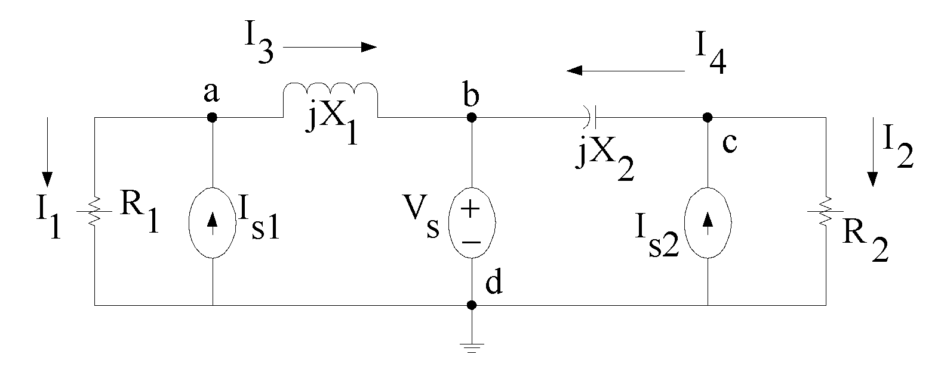

Fig.3.

4. Fig.4 shows an impedance-matching network for maximum power transfer.

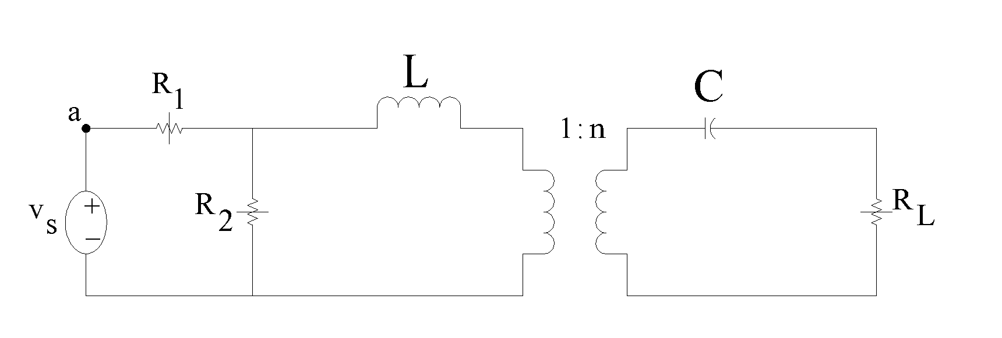

Fig.4.

1. Determine the value of R2 that will make RL absorb maximum power.
2. What is the value of maximum power dissipated in RL?

The various component values are given by: n =2, vs = 20 cos(5000t) volts, R1 = 8k ohms, RL = 19.2k ohms, L = 10 mH, C = 1 µF.

(9 marks)

**3 of 6/-**

5. Fig.5 shows a three-phase network. Calculate the complex power (P + jQ) in each of the impedances Z1, Z2 and Z3.

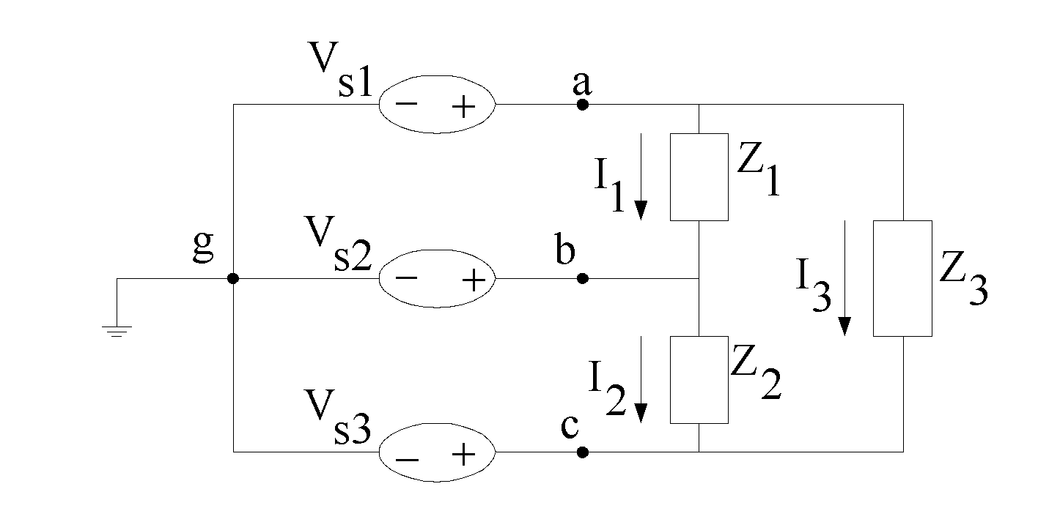

Fig.5.

The various component values are given by: vs1 = 200 cos(377t) volts, vs2 = 200 cos (377t + 120o) volts, vs3 = 200 cos(377t + 240o) volts, Z1 = (20 + j30) ohms, Z2 = - j 40 ohms and Z3 = 10 ohms.

(Hint: use **Ohms law and KVL**).

(9 marks)

6. Consider the magnetic structure shown below.

1. Draw the analogous magnetic circuit, clearly showing the MMF, and its value, the flux φ and the reluctances.
2. Compute the total reluctance of the magnetic circuit. Neglect the fringing effect of the air-gap.
3. Determine the flux density (B) in the (metal) core when i = 8 A.

(9 marks)

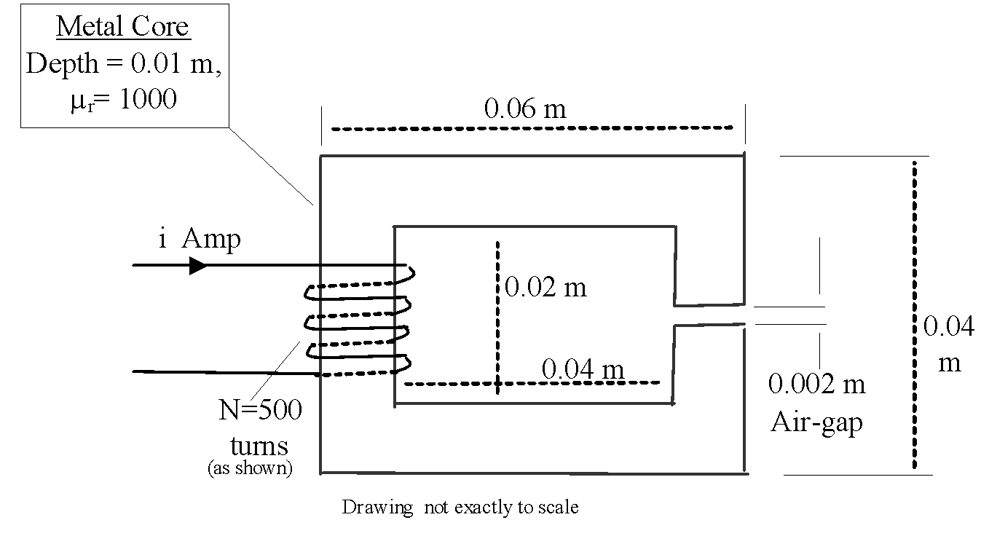

**4 of 6/-**

7. Consider the shunt-connected dc motor shown below. Its field resistance (Rf) was adjusted to yield kaφ = 3.2 V-s/rad. When operating with a certain mechanical load, it draws 83600 W of power from the 440 V dc line/source. Compute:

A) The value of the back EMF (Eb).

B) The speed (ωm).

C) The developed torque,

D) The output (mechanical) power.

(8 marks)

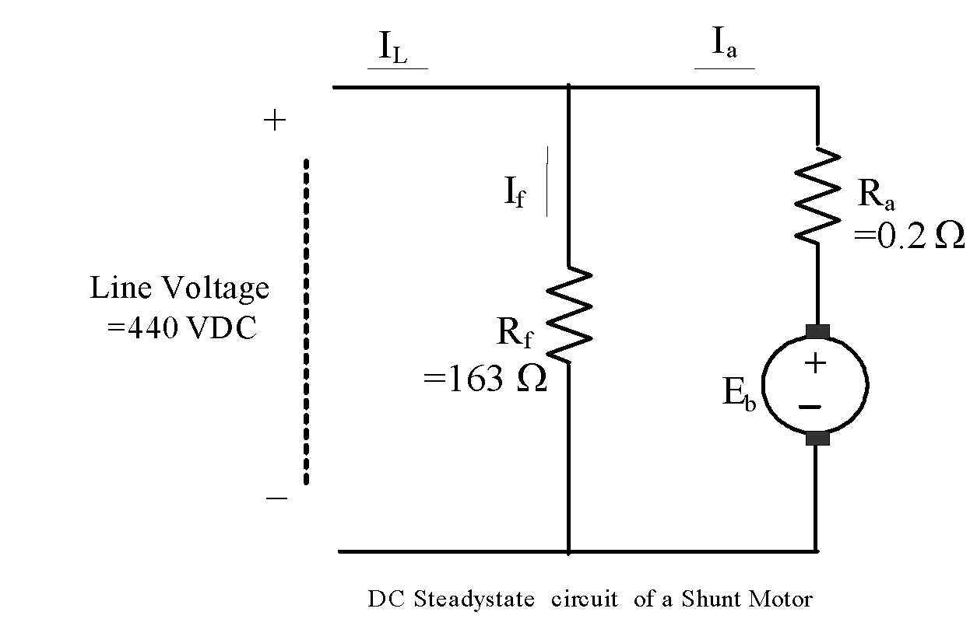

**5 of 6/-**

FORMULAS

**Voltage & Current dividers** : (Resistors shown, but equally valid for impedances Z)

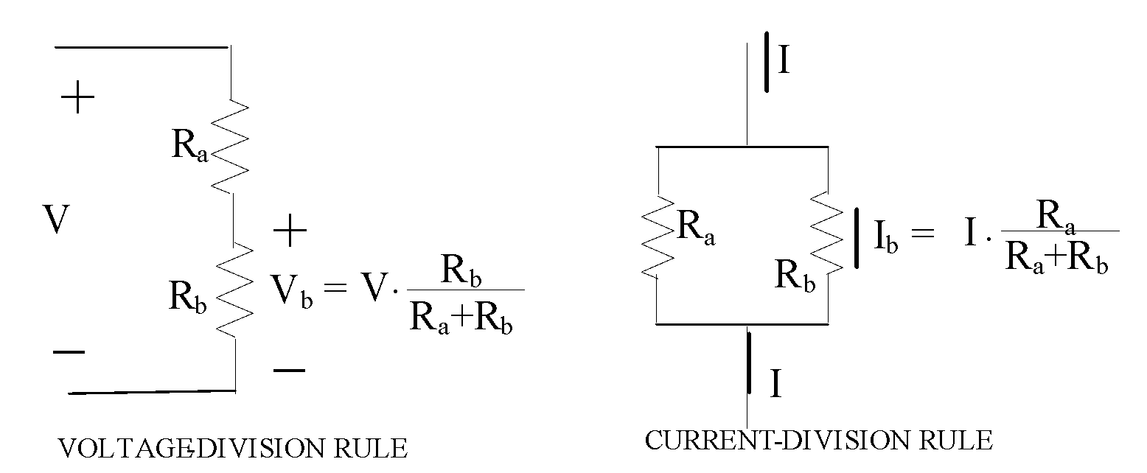

Complex Number normalization: 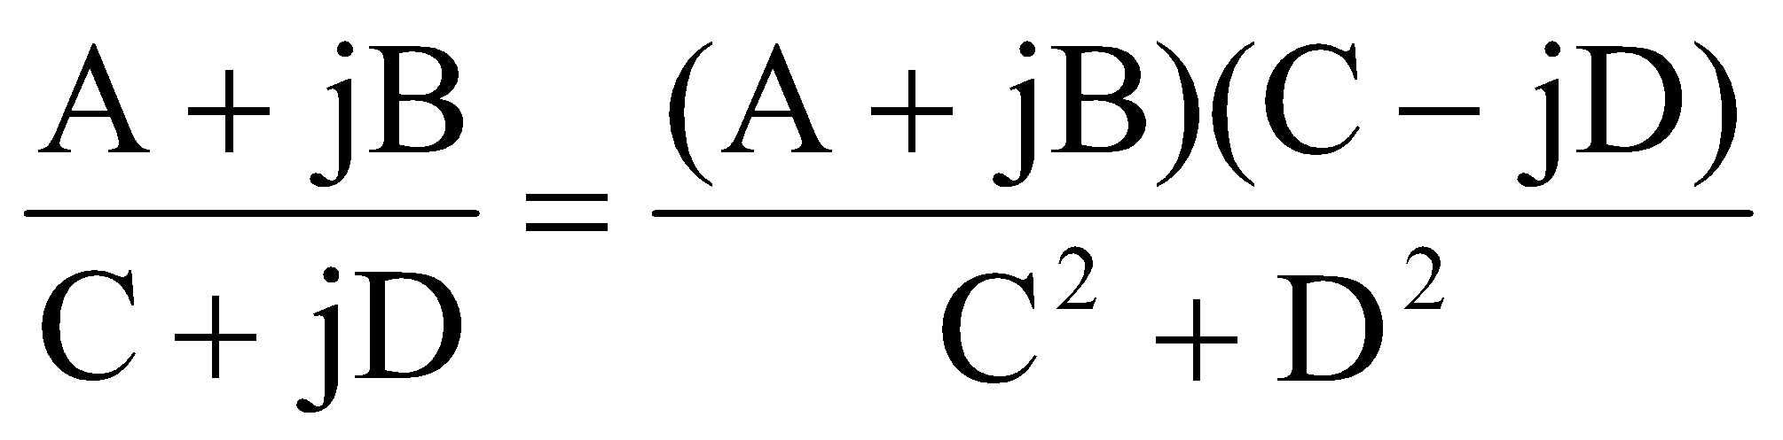

**Impedances**: ω (radians/sec)= 2π f(Hz), ZR = R0o , ZL = jωL = ωL+90o, ZL = 1/jωC = − j /ωC = (1/ωC)−90o.

Series impedances: Zeq = Z1 + Z2 + … + Zn. Parallel impedances: 1/Zeq = 1/Z1 + 1/Z2 +…+ 1/Zn

**DC Power**: PR = IV = I2R = V2 / R

**AC Power**:

Complex Power S = P + jQ = VI* where I* is the complex conjugate of (phasor) I .

Apparent power (VA), S = V I, where V and I are the RMS values of voltage and current.

Real power (Watts): P = VI cos θ, where θ is the phase angle between V & I, which can also be the “angle of the load.” P = I2 Re(Z) where Z is the impedance through which one wants to calculate “P.” Reactive power: Q = VI sin θ (VARs), Q = P tan θ and Q= I2 Im(Z).

**Transformers:** Voltage & Current transformations:Vp/Vs = Np/Ns = Is /Ip, where Np & Ns are the number of turns on the primary & secondary. Impedance transformation: Zp = (Np/Ns)2Zs.

**Magnetic circuits:** MMF = Ni , N= # of turns, i = current (A). Flux φ = MMF/Rm (Wb), where Rm = Reluctance = l /μA , (A-turn/Wb), l = average path length(m), A = area of cross-section (m2) and Permeability μ = μr μo , where μr = relative permeability, μo= 4π10-7 H/m.

**DC Motors:** For a shunt connected motor Iline = If + Ia. Field current: If = Vf/Rf. Armature equation: Va = Ea + IaRa. Back-emf : Eb = kaφ ωm. Torque developed: T = kaφ ia, where ka is a constant, φ is the ‘flux per pole’, ωm is the speed (radians/sec), and i (A) is the armature current. Load(mech) power: P = Tωm. Radians/sec to RPM conversion: ω(radians/sec) = (2π/60)N(rpm)

6 of 6/-